Black Dog Animal Rescue and Cheyenne Animal Shelter’s
CaPAWtal City Pet Fest
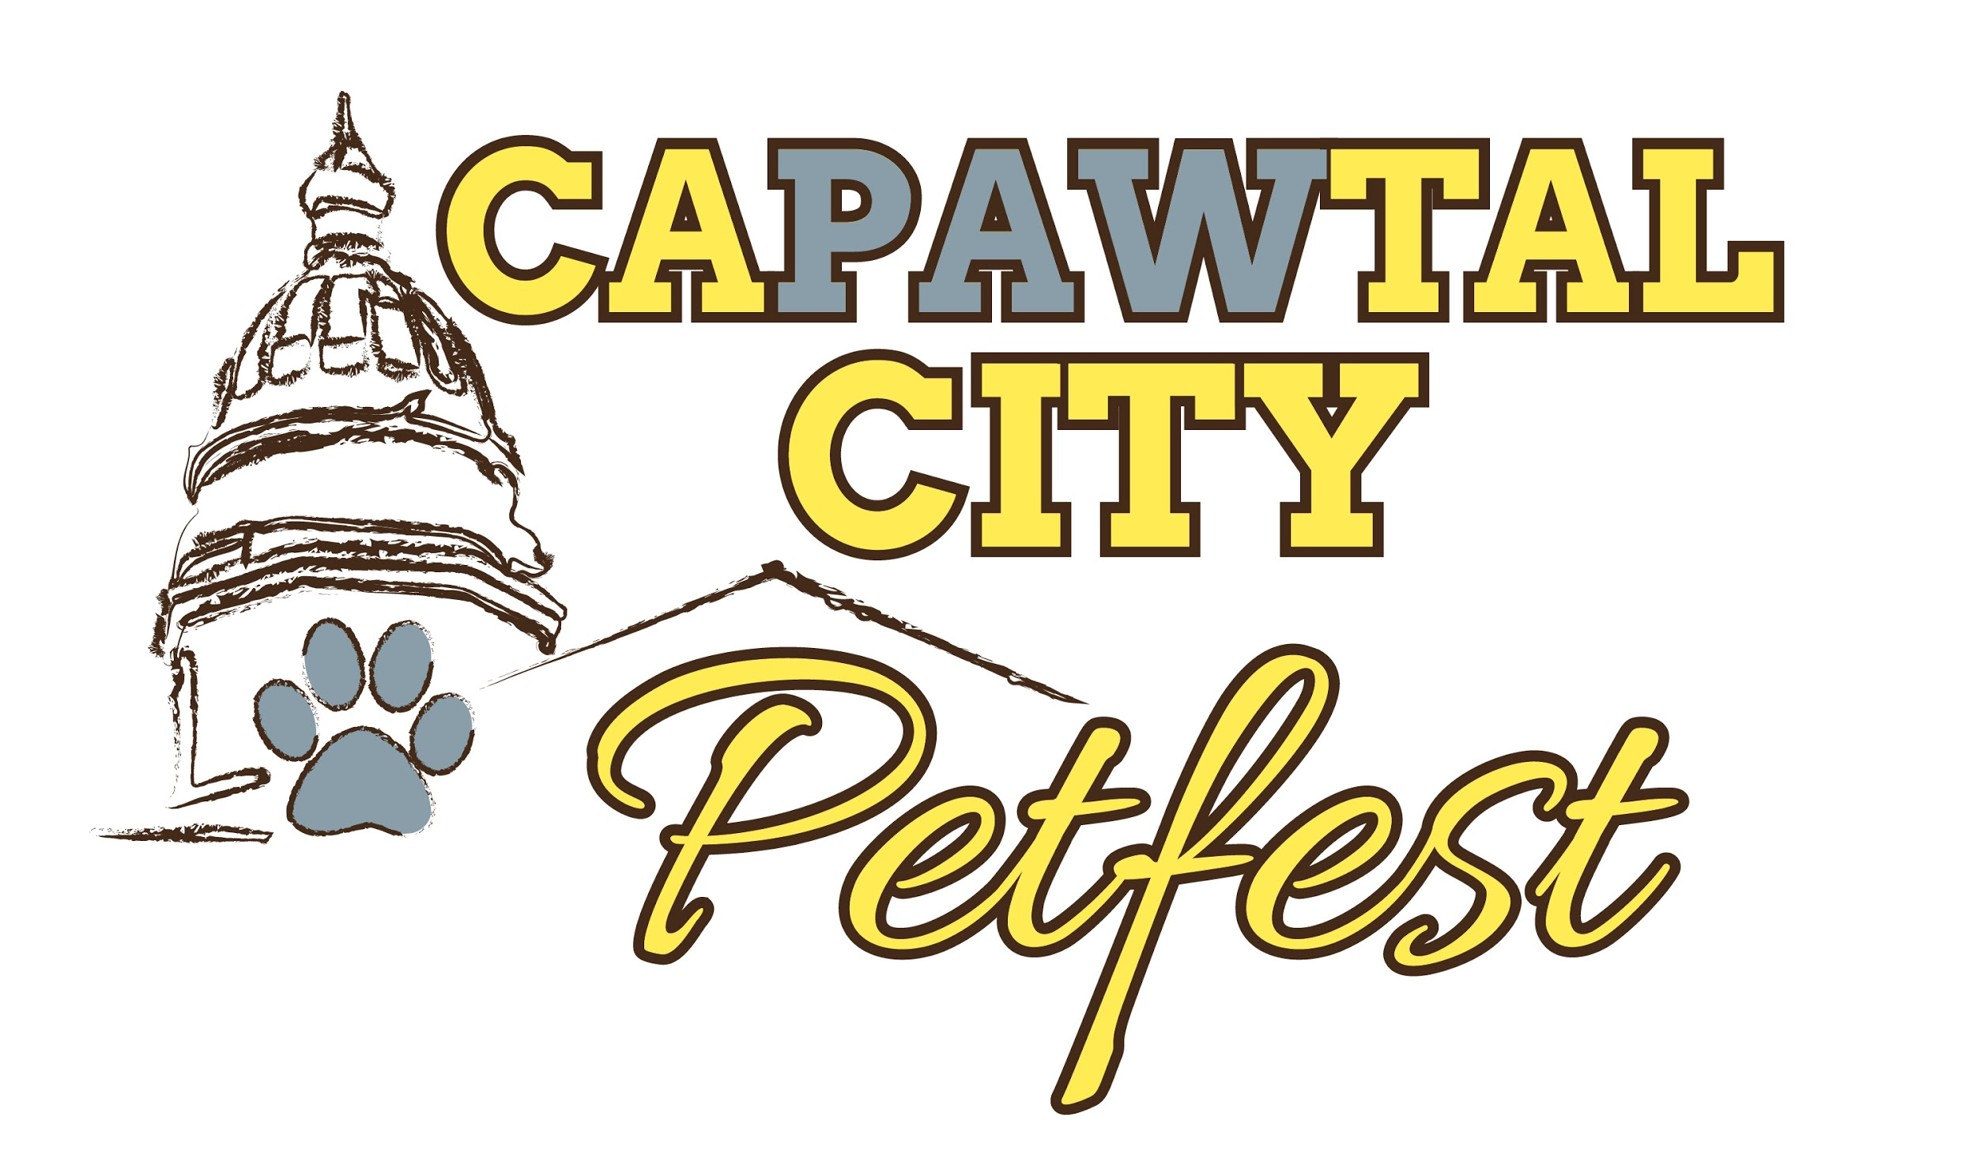
Saturday, June 11, 2016
9 am to 12 pm
Lions Park Amphitheatre
Cheyenne, WY

The CaPAWtal City Pet Fest (CCPF) committee would like to thank you for your support and participation in this event.
Booth Space will be assigned as the event nears. You will receive a booth assignment by email on or around June 6th. Set-up will begin at 7 am on the morning of the event.
Please be sure to read the mutual understandings, sign the form and return it along with the registration form and fee.
If you have any questions concerning CCPF, please contact Emilee Intlekofer at
307-214-6600 or emilee@bdar.org
Mutual Understandings
(Please initial each)
- No product or service will be guaranteed exclusivity _________
- No tables or shade will be provided by BDAR _________
- Booth Space is assigned and determined by the SMF committee _________
- No electricity provided (generators allowed) _________
- Booths are responsible for cleaning their own area after the event _________
- BDAR reserves the right to relocate any booths for any reason _________
- Be mindful of sprinkler heads when setting up tents _________
- If you choose to set up a tent/awning. Ropes/stakes must be flagged _________
- After unloading, vehicles must be moved from the main parking lot _________
- Shelters and Rescue Groups: All animals available for adoption must be spayed/neutered and current on all vaccinations _________

_________________________, does hereby agree and hold harmless and indemnify Black Dog Animal Rescue and Cheyenne Animal Shelter and their individual members against any legal proceeding arising out of participation in the CaPAWtal City Pet Fest. I am the person responsible for our booth and I understand and agree to comply with the CaPAWtal City Pet Fest Mutual Understandings.
_____________________________________ ____________________________________
Signature Date

Return this form along with registration form and payment to:
Black Dog Animal Rescue
Attn: Emilee
3619 Evans Avenue, Suite B
Cheyenne, Wyoming 82001

